Task 8 – BL_DM Layer (Star Schema)
This task focused on loading data from the 3NF layer into the dimensional (BL_DM) layer and ensuring that all procedures are incremental and repeatable.
At the start, all dimension tables and the fact table already existed in BL_DM with primary keys, foreign keys, NOT NULL constraints and sequences. Fact grain was defined as:
One row per transaction per source system.
During implementation it became clear that this grain must be strictly enforced. Since transaction IDs overlap between ONLINE and RETAIL sources, a composite uniqueness constraint was required:
UNIQUE (sales_src_id, source_system)
Without this, duplicates were possible. After adding the correct constraint, the fact table behaved as expected.

Type 1 Dimensions
All Type 1 dimensions (products, suppliers, employees, stores, deliveries, landings, payments) were implemented incrementally.
Process:
- Read from 3NF layer
- Insert new business keys
- Update attributes if values changed
- Do nothing if identical
- Log result
Each dimension includes:
- Surrogate key
- Business key
- Insert/update timestamps
- Default UNKNOWN row (-1) for foreign key safety
Initially, some procedures updated all rows on each execution due to unconditional update logic. This was fixed by adding proper change detection using IS DISTINCT FROM conditions.
After correction:
First run → rows inserted
Second run → rows_affected = 0
This confirms idempotency.
SQL files also uploaded.
.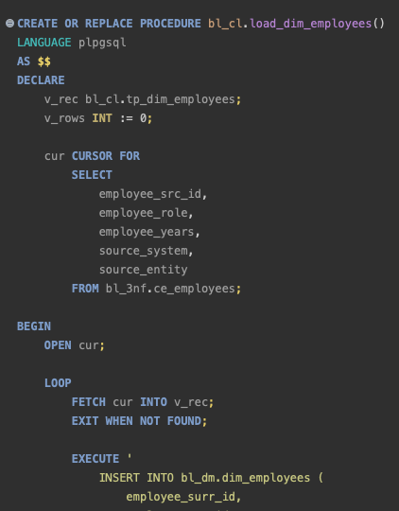
Here are the initial attempts resulting in repeated >0 rows affected, which was fixed.
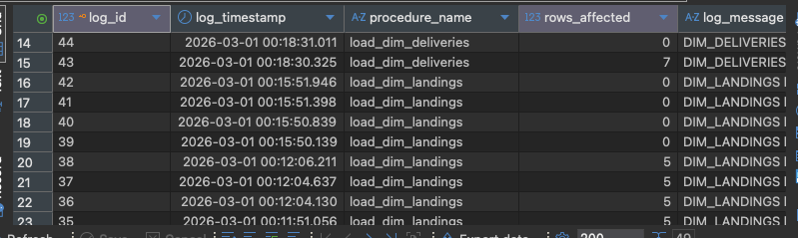

SCD Type 2 – Customers
Customer dimension was implemented as SCD Type 2.
Logic:
- If customer does not exist → insert new version
- If exists and attributes changed:
  - Close old version (update end_dt and is_active)
  - Insert new version with new surrogate key
- If unchanged → no action
Fact joins correct version using:
sale_date BETWEEN start_dt AND end_dt
Testing confirmed:
- New version is created when source data changes
- Old version is closed correctly
- Second execution results in 0 rows affected

Fact Table (fct_sales)
Initial implementation used cursor-based row-by-row processing.
This worked logically but was extremely slow (took over 30 minutes for large dataset).
The procedure was rewritten using a set-based INSERT INTO … SELECT with LEFT JOINs to all dimensions.
Surrogate keys are resolved via joins.
If no match is found, fallback value -1 is used.
Profit is calculated as:
price_sale - product_cost
Duplicate prevention is handled via:
NOT EXISTS (sales_src_id, source_system)
After switching to set-based logic:
~1,000,000 rows loaded efficiently.
Second execution → rows_affected = 0.
Performance improved significantly compared to cursor approach.
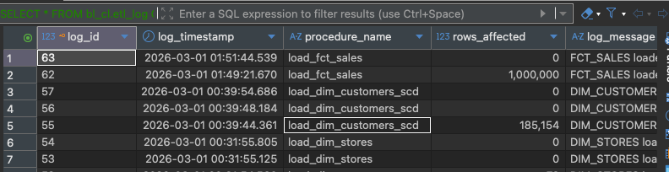

Findings
- Grain definition is critical. Without composite uniqueness, fact duplicates occurred.
- Change detection in Type 1 dimensions must be explicit, otherwise full-table updates happen.
- SCD2 logic must be date-aware to maintain historical correctness.
- Row-by-row processing is not suitable for large fact tables. Set-based loading is required.
- UNKNOWN (-1) rows are necessary to satisfy foreign key constraints when dimension data is missing.

Final state
All BL_DM objects verified.
All dimension procedures incremental.
SCD2 works correctly.
Fact table loads incrementally and efficiently.
Logging confirms repeatability.
Second execution of any procedure results in 0 rows affected (unless source changes).

